Product Upgrade Guide v4.0.5.0

Contents
1 Document Control 5
1.1 Author 5
1.2 Document Summary 5
1.3 Document History 5
1.4 Reference documents 5
1.5 Distribution 5
1.6 Quality Assurance 5
2 Introduction 6
2.1 Purpose 6
2.2 Products Covered by this Guide 7
2.3 Order in which to Upgrade Products 8
2.4 Pre-Requisites to Upgrade 9
3 Network Manager 10
3.1 Installation of the Network Manager Software files 10
3.2 Network Manager Server Upgrade 11
3.2.1 Before you Start 11
3.2.2 Typical problems that you may encounter 11
3.2.3 Upgrade of Network Manager 11
3.2.4 Mandatory Configuration 12
3.2.5 Additional Configuration 13
3.2.6 Spatial Configuration 13
4 Street Gazetteer Manager 14
4.1 Implementation of the Street Gazetteer Manager Software files 14
4.2 Street Gazetteer Manager Server Upgrade 15
4.2.1 Before you Start 15
4.2.2 Typical problems that you may encounter 15
4.2.3 Upgrade of Street Gazetteer Manager 15
4.2.4 Mandatory Configuration 16
4.2.5 XSD Files 17
5 TMA Manager 18
5.1 Implementation of the TMA Manager Software files 18
5.2 TMA Manager Server Upgrade 19
5.2.1 Before you Start 19
5.2.2 Typical problems that you may encounter 19
5.2.3 Upgrade of TMA Manager 20
5.2.4 Mandatory Configuration 21
6 TMA API 27
6.1 Implementation of the TMA API Software files 27
6.2 TMA API Server Upgrade 28
6.2.1 Before you Start 28
6.2.2 Typical problems that you may encounter 28
6.3 TMA External Notice API Implementation 29
6.3.1 Deployment of API Software Files 29
6.3.2 API Server Component Install 29
7 Streetworks Manager 31
7.1 Implementation of the Streetworks Manager Software files 31
7.2 Streetworks Manager Server Upgrade 32
7.2.1 Before you Start 32
7.2.2 Typical problems that you may encounter 32
7.2.3 Upgrade of Streetworks Manager 32
7.2.4 Mandatory Configuration 33
7.2.5 Additional Configuration 34
7.2.6 Spatial Configuration 34
8 Maintenance Manager 35
8.1 Implementation of the Maintenance Manager Software files 35
8.2 Maintenance Manager Server Upgrade 36
8.2.1 Before you Start 36
8.2.2 Typical problems that you may encounter 36
8.2.3 Upgrade of Maintenance Manager 36
8.2.4 Mandatory Configuration 37
8.2.5 Additional Configuration 38
8.2.6 Spatial Configuration 38
9 Public Enquiry Manager 39
9.1 Implementation of the Public Enquiry Manager Software files 39
9.2 Public Enquiry Manager Server Upgrade 40
9.2.1 Before you Start 40
9.2.2 Typical problems that you may encounter 40
9.2.3 Upgrade of Public Enquiry Manager 40
9.2.4 Mandatory Configuration 41
9.2.5 Additional Configuration 42
9.2.6 Spatial Configuration 42
10 Asset Valuation Manager 43
10.1 Implementation of the Asset Valuation Manager Software files 43
10.2 Asset Valuation Manager Server Upgrade 44
10.2.1 Before you Start 44
10.2.2 Typical problems that you may encounter 44
10.2.3 Upgrade of Asset Valuation Manager 44
10.2.4 Mandatory Configuration 45
10.2.5 Additional Configuration 46
10.2.6 Spatial Configuration 46
11 Accidents Manager 47
11.1 Implementation of the Accidents Manager Software files 47
11.2 Accidents Manager Server Upgrade 48
11.2.1 Before you Start 48
11.2.2 Typical problems that you may encounter 48
11.2.3 Upgrade of Accidents Manager 48
11.2.4 Mandatory Configuration 49
11.2.5 Additional Configuration 50
11.2.6 Spatial Configuration 50
12 Public Rights Of Way Manager 51
12.1 Implementation of the Public Rights Of Way Manager Software files 51
12.2 Public Rights Of Way Manager Server Upgrade 52
12.2.1 Before you Start 52
12.2.2 Typical problems that you may encounter 52
12.2.3 Upgrade of Public Rights Of Way Manager 52
12.2.4 Mandatory Configuration 53
12.2.5 Additional Configuration 54
12.2.6 Spatial Configuration 54
13 Street Lighting Manager 55
13.1 Implementation of the Street Lighting Manager Software files 55
13.2 Street Lighting Manager Server Upgrade 56
13.2.1 Before you Start 56
13.2.2 Typical problems that you may encounter 56
13.2.3 Upgrade of Street Lighting Manager 56
13.2.4 Mandatory Configuration 57
13.2.5 Additional Configuration 58
13.2.6 Spatial Configuration 58
14 Schemes Manager 59
14.1 Implementation of the Schemes Manager Software files 59
14.2 Schemes Manager Server Upgrade 60
14.2.1 Before you Start 60
14.2.2 Typical problems that you may encounter 60
14.2.3 Upgrade of Schemes Manager 60
14.2.4 Mandatory Configuration 61
14.2.5 Additional Configuration 62
14.2.6 Spatial Configuration 62
15 Structures Manager 63
15.1 Implementation of the Structures Manager Software files 63
15.2 Structures Manager Server Upgrade 64
15.2.1 Before you Start 64
15.2.2 Typical problems that you may encounter 64
15.2.3 Upgrade of Structures Manager 64
15.2.4 Mandatory Configuration 65
15.2.5 Additional Configuration 66
15.2.6 Spatial Configuration 66
16 Traffic Interface Manager 67
16.1 Implementation of the Traffic Interface Manager Software files 67
16.2 Traffic Interface Manager Server Upgrade 68
16.2.1 Before you Start 68
16.2.2 Typical problems that you may encounter 68
16.2.3 Upgrade of Traffic Interface Manager 68
16.2.4 Mandatory Configuration 69
16.2.5 Additional Configuration 70
16.2.6 Spatial Configuration 70

- Document Control
  - Author
Exor Development

  - Document Summary
This document covers steps involved in upgrading the components for Network Manager, Street Gazetteer Manager and TMA Manager.

  - Document History

Document History
Revision | Date | By | Description
1.0 | 01-Sep-2008 | Exor Development | First Edition

  - Reference documents
None

  - Distribution
Exor Customers, Partners and Staff

  - Quality Assurance
Document Details
File | Prepared By
0000.doc | Exor Development
Document Name | Reviewed By
Product Upgrade Guide v4.0.5.0 | Colin Stewart
Version | Approved for issue by
1.0 | Colin Stewart
Date of Issue | Support Manager
01-Sep-2008 | Graham Anns

- Introduction
  - Purpose
This guide covers steps involved in upgrading the components for
- Network Manager
- Street Gazetteer Manager
- TMA Manager
- Street Works Manager
- Maintenance Manager
- Public Enquiry Manager
- Asset Valuation Manager
- Accidents Manager
- Public Rights Of Way Manager
- Street Lighting Manager
- Schemes
- Structures Manager
- Traffic Interface Manager

Each product upgrade is split into two distinct stages,

- Stage 1 – Implementation of the Software files
- Stage 2 – Upgrade of the Server

  - Products Covered by this Guide
Table 1 lists the relevant products that are covered by this guide.

Product | Install | Upgrade From 4.0.4.0 | Upgrade From 4.0.4.3 | Upgrade From 4.0.4.6
Network Manager | ✗ |  | n/a | 
Street Gazetteer Manager | ✗ | n/a | n/a | 
TMA Manager | ✗ | n/a | n/a | 
Street Works Manager | ✗ |  | n/a | n/a
Maintenance Manager | ✗ |  |  | n/a
Public Enquiry Manager | ✗ |  |  | n/a
Asset Valuation Manager | ✗ |  | n/a | n/a
Accidents Manager | ✗ |  | n/a | n/a
Public Right Of Way Manager | ✗ |  | n/a | n/a
Street Lighting Manager | ✗ |  | n/a | n/a
Schemes | ✗ |  | n/a | n/a
Structures Manager | ✗ |  | n/a | n/a
Traffic Interface Manager | ✗ |  | n/a | n/a
Table 1: List of products covered by this guide

  - Order in which to Upgrade Products
Table 2 lists the order in which to upgrade the products in this release.

Product to install | Order to install
Network Manager | 1
Street Gazetteer Manager | 2
TMA Manager | 3
Street Works Manager | 4
Maintenance Manager | 5
Public Enquiry Manager | 6
Asset Valuation Manager | 7
Accidents Manager | 8
Public Right Of Way Manager | 9
Street Lighting Manager | 10
Schemes | 11
Structures Manager | 12
Traffic Interface Manager | 13
Table 2: Order in which to upgrade products

  - Pre-Requisites to Upgrade
It is assumed that the audience of this document understand the configuration of the servers being upgraded and are sufficiently proficient with SQL*Plus. It is also assumed that the terminology used in this document is understood by the reader.

NB. The instructions for installation of the software describes the installation of all the software into a single area (usually referred to as the ‘Client’). The instructions for upgrading the Server (your Highways schema) assume you have access to the database from the ‘Client’.

Your configuration and server access may differ from this; the InstallShield can still be used for installation. For example, you may have to install the Client software on the Application Server and the Server software on the Database Server for reasons of database access availablilty from the Application Server.

If in any doubt please contact support@exorcorp.com.

Before attempting to upgrade, you should ensure that;

- the appropriate software components are installed and are compatible with the exor certification matrix. The certification matrix can be downloaded from the Client area of the exor website.

- all users are disconnected from the system

- the highways listener processes are not running

- a database export of the owner of Highways owner has been taken.

- You MUST copy the current <exor_base> directory and sub-directory structure and contents to a new area (e.g. <exor_base4050>). The installation can then continue onto <exor_base>.
This is to ensure that the copy you have taken is for backup and for reference in case of any issues that may occur.

ANY OTHER PRE_REQUISITES eg. shutting down web services, etc

SEE SERVICES

- Network Manager
  - Installation of the Network Manager Software files
To install the software components for Network Manager execute the setup_network_manager_4050.exe and follow the on-screen prompts.

Extremely Important (For TMA users):

This is a patch release to be installed on top of release 4.0.4.6

It is crucial that when selecting the ‘Destination Folder’, you select that directory under which the existing 4.0.4.6 software resides.

When the wizard completes, the necessary client and server software files will have been installed.

Notes:
A password is required to be entered during this process. If you are not sure of the password contact support@exorcorp.com.

  - Network Manager Server Upgrade
This chapter provides details of steps involved in upgrading the server components for Network Manager.

Important:
This product will require upgrading before TMA Manager and Street Gazetteer Manager.

    - Before you Start

Before proceeding please ensure that the pre-requisites mentioned in Section 2.3 of this document are met.

Also, please be aware of the following;

Where instructed to change to a directory before running a script, it is assumed that you are running SQL*PLUS from a DOS Command prompt.

If you are running SQL*PLUS in windows you should set the 'start in' directory of the SQL*PLUS shortcut to simulate the change of directory.

If you do not run SQL*PLUS from the directory stated in each step of the guide, the installation will fail.

Also, whilst following the instructions in this section you will be required to know the location of <exor_base>. You may recall that whilst undertaking the tasks in Section 3.1 you will have implemented software into the location referred to as <exor_base>, for example, C:\EXOR.

    - Typical problems that you may encounter

It is possible that, when you are running some of the upgrade scripts, errors may be reported saying that objects already exist in the database or that columns already exist on tables. These errors can generally be ignored. If you are in any doubt, please contact the Exor support desk for guidance.

The upgrade procedures will also attempt to install database roles in the highways owner account that are necessary for the system to operate correctly. You may find that errors are produced when running the upgrade scripts to the effect that the role names being created are already used by existing roles or users. These errors can be ignored as they simply mean that the roles being created already exist.

Also during upgrade Warning messages may appear saying that compilation errors have occurred. These warnings can be ignored, since invalid objects will be recompiled prompt later on in the upgrade. However it will be of concern if compilation errors still occur following the re-compilation.

    - Upgrade of Network Manager

This section describes the steps necessary to upgrade Network Manager to 4.0.5.0

Important
The server upgrade relies on invoking scripts shipped with the previous release. Therefore it is essential that the software was installed into the correct destination folder, as instructed in the previous chapter.

To upgrade the base data and objects for the Network Manager modules;

- Change directory to <exor_base>\nm3\install

- Login to SQL*PLUS as the highways owner on the client PC

- Run the following command (whether upgrading from the 4040 release or the 4046 release)

start nm4040_nm4050.sql

- You will be prompted to enter the path of the location of your highways software. This should be name of the directory, including disk identifier and a trailing slash character, referred to as <exor_base>.

For example, if you installed your highways software in a directory called EXOR on your C drive, you would enter the following when prompted.

C:\EXOR\

- When you have supplied this value, you will be prompted to confirm that it is correct and asked whether you wish to continue.

- If the value specified is not correct or does not end with a slash character, you will be given an error message and the installation script will abort. You will then need to login to SQL*PLUS again and rerun the script.

- When the script has completed, all the Network Manager objects and data will have been upgraded.

Checking Log File(s)

The following log files are produced in the working directory. At the end of the upgrade, they can be viewed to check for any errors that could have occurred during the upgrade process.

nm404x_nm4050_1_<date&time>.LOG
nm404x_nm4050_2_<date&time>.LOG

Log files should be emailed to support@exorcorp.com to allow exor support staff to verify the upgrade has been successful.

Due to interdependencies between some Exor products, please ignore all compilation errors until all of your products have been upgraded.

    - Mandatory Configuration

exor_version.txt

Before accessing Network Manager you must check the file exor_version.txt.

This file is referenced in Windows Registry setting ‘EXOR_VERSION’ and by default can be located in the <exor_base>\bin directory.

Ensure that the entry for Network Manager is set accordingly;

NET=4.0.5.0
HIG=4.0.5.0
AST=4.0.5.0
DOC=4.0.5.0
WMP=4.0.5.0

    - Additional Configuration

Consult the documentation that accompanies this release for details of any additional configuration that may be required following an upgrade.

For example, to obtain details of product options, and for details of new product features/amendments.

Important:
It is highly recommended that you do this before attempting to use the application.

    - Spatial Configuration

Specific information regarding the registration of spatial layers can be found in the “Locator and Web Mapping” document.

- Street Gazetteer Manager
  - Implementation of the Street Gazetteer Manager Software files
To install the software components for Street Gazetteer Manager execute the setup_street_gazetteer_manager_4050.exe and follow the on-screen prompts.

Extremely Important:

This is a patch release to be installed on top of release 4.0.4.6

It is crucial that when selecting the ‘Destination Folder’, you select that directory under which the existing 4.0.4.6 software resides.

When the wizard completes, the necessary client and server software files will have been installed.

Notes:
A password is required to be entered during this process. If you are not sure of the password contact support@exorcorp.com.

  - Street Gazetteer Manager Server Upgrade
This chapter provides details of steps involved in upgrading the server components for Street Gazetteer Manager.

Important:
This product will require upgrading after Network Manager and before TMA Manager.

    - Before you Start

Before proceeding please ensure that the pre-requisites mentioned in Section 2.3 of this document are met.

Also, please be aware of the following;

Where instructed to change to a directory before running a script, it is assumed that you are running SQL*PLUS from a DOS Command prompt.

If you are running SQL*PLUS in windows you should set the 'start in' directory of the SQL*PLUS shortcut to simulate the change of directory.

If you do not run SQL*PLUS from the directory stated in each step of the guide, the installation will fail.

Also, whilst following the instructions in this section you will be required to know the location of <exor_base>. You may recall that whilst undertaking the tasks in Section 4.1 you will have implemented software into the location referred to as <exor_base>, for example, C:\EXOR.

    - Typical problems that you may encounter

It is possible that, when you are running some of the upgrade scripts, errors may be reported saying that objects already exist in the database or that columns already exist on tables. These errors can generally be ignored. If you are in any doubt, please contact the Exor support desk for guidance.

The upgrade procedures will also attempt to install database roles in the highways owner account that are necessary for the system to operate correctly. You may find that errors are produced when running the upgrade scripts to the effect that the role names being created are already used by existing roles or users. These errors can be ignored as they simply mean that the roles being created already exist.

Also during upgrade Warning messages may appear saying that compilation errors have occurred. These warnings can be ignored, since invalid objects will be recompiled prompt later on in the upgrade. However it will be of concern if compilation errors still occur following the re-compilation.

    - Upgrade of Street Gazetteer Manager

This section describes the steps necessary to upgrade Street Gazetteer Manager to 4.0.5.0

Important
The server upgrade relies on invoking scripts shipped with the previous release. Therefore it is essential that the software was installed into the correct destination folder, as instructed in the previous chapter.

To upgrade the base data and objects for the Street Gazetteer Manager modules;

- Change directory to <exor_base>\nsg\install

- Login to SQL*PLUS as the highways owner on the client PC

- The same script is used to upgrade from the previous version shown in Section 2.2.
Run the following command

start nsg4046_nsg4050.sql

- You will be prompted to enter the path of the location of your highways software. This should be name of the directory, including disk identifier and a trailing slash character, referred to as <exor_base>.

For example, if you installed your highways software in a directory called EXOR on your C drive, you would enter the following when prompted.

C:\EXOR\

- When you have supplied this value, you will be prompted to confirm that it is correct and asked whether you wish to continue.

- If the value specified is not correct or does not end with a slash character, you will be given an error message and the installation script will abort. You will then need to login to SQL*PLUS again and rerun the script.

- When the script has completed, all the Street Gazetteer Manager objects and data will have been upgraded.

Checking Log File(s)

The following log files are produced in the working directory. At the end of the upgrade, they can be viewed to check for any errors that could have occurred during the upgrade process.

nsg4046_nsg4050_1_<date&time>.LOG
nsg4046_nsg4050_2_<date&time>.LOG

Log files should be emailed to support@exorcorp.com to allow exor support staff to verify the upgrade has been successful.

Due to interdependencies between some Exor products, please ignore all compilation errors until all of your products have been upgraded.

    - Mandatory Configuration

exor_version.txt

Before accessing Street Gazetteer Manager you must check the file exor_version.txt.

This file is referenced in Windows Registry setting ‘EXOR_VERSION’ and by default can be located in the <exor_base>\bin directory.

Ensure that the entry for Street Gazetteer Manager is set accordingly;

NSG=4.0.5.0

    - XSD Files

This step is mandatory for this release (even if XSD’s have been registered before).

To simplify XSD configuration, from release 4.0.4.5 onwards, the registration of all EToN XSD’s will be handled by Street Gazetteer Manager. There is no longer a need to register these XSDs during a TMA install/upgrade

The Street Gazetteer Manager upgrade to 4.0.4.5 will de-register any existing XSD’s - therefore the following configuration is required.

Copy the .xsd files from <exor_base>\nsg\admin\xsd into a directory on the database server.

Log into the Highways By Exor application and open the ‘Directories’ module

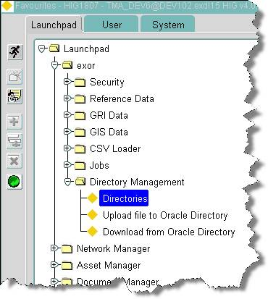

Ensure that the directory with the name ‘NSG_XSD_DIRECTORY’ has a path set that points to the location that you have just copied .xsd files into e.g.

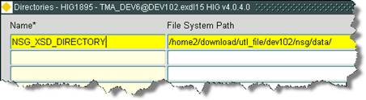

The XSD files must then be registered with Oracle XMLDB by running the script <exor_base>\nsg\admin\xsd\register_eton_schemas.sql
- TMA Manager
  - Implementation of the TMA Manager Software files

To install the software components for TMA Manager execute the setup_tma_manager_4050.exe and follow the on-screen prompts.

Extremely Important:

This is a patch release to be installed on top of release 4.0.4.6

It is crucial that when selecting the ‘Destination Folder’, you select that directory under which the existing 4.0.4.6 software resides.

When the wizard completes, the necessary client and server software files will have been installed.

Notes:
A password is required to be entered during this process. If you are not sure of the password contact support@exorcorp.com.

  - TMA Manager Server Upgrade
This chapter provides details of steps involved in upgrading the server components for TMA Manager.

Important:
This product will require upgrading after Network Manager and Street Gazetteer Manager.

    - Before you Start

Before proceeding please ensure that the pre-requisites mentioned in Section 2.3 of this document are met.

Also, please be aware of the following;

Extremely Important:

The TMA Web Server should be upgraded to 4.0.5.0 before upgrading TMA Manager.

The 4.0.5.0 release of the TMA Web Service can be found on the Exor download site (TMAWebService_4050.zip). Download this zip and follow the instructions in the Install/Upgrade Guide contained in the zip file.

Before upgrading TMA Manager shutdown the TMA Web Server And Restart it after successfully upgrading TMA Manager.

Where instructed to change to a directory before running a script, it is assumed that you are running SQL*PLUS from a DOS Command prompt.

If you are running SQL*PLUS in windows you should set the 'start in' directory of the SQL*PLUS shortcut to simulate the change of directory.

If you do not run SQL*PLUS from the directory stated in each step of the guide, the installation will fail.

Also, whilst following the instructions in this section you will be required to know the location of <exor_base>. You may recall that whilst undertaking the tasks in Section 5.1 you will have implemented software into the location referred to as <exor_base>, for example, C:\EXOR.

    - Typical problems that you may encounter

It is possible that, when you are running some of the upgrade scripts, errors may be reported saying that objects already exist in the database or that columns already exist on tables. These errors can generally be ignored. If you are in any doubt, please contact the Exor support desk for guidance.

The upgrade procedures will also attempt to install database roles in the highways owner account that are necessary for the system to operate correctly. You may find that errors are produced when running the upgrade scripts to the effect that the role names being created are already used by existing roles or users. These errors can be ignored as they simply mean that the roles being created already exist.

Also during upgrade Warning messages may appear saying that compilation errors have occurred. These warnings can be ignored, since invalid objects will be recompiled prompt later on in the upgrade. However it will be of concern if compilation errors still occur following the re-compilation.

    - Upgrade of TMA Manager

This section describes the steps necessary to upgrade TMA Manager to 4.0.5.0

Important
The server upgrade relies on invoking scripts shipped with the previous release. Therefore it is essential that the software was installed into the correct destination folder, as instructed in the previous chapter.

To upgrade the base data and objects for the TMA Manager modules;

- Change directory to <exor_base>\tma\install

- Login to SQL*PLUS as the highways owner on the client PC

- The same script is used to upgrade from the previous version shown in Section 2.2.
Run the following command

start tma4046_tma4050.sql

- You will be prompted to enter the path of the location of your highways software. This should be name of the directory, including disk identifier and a trailing slash character, referred to as <exor_base>.

For example, if you installed your highways software in a directory called EXOR on your C drive, you would enter the following when prompted.

C:\EXOR\

- When you have supplied this value, you will be prompted to confirm that it is correct and asked whether you wish to continue.

- If the value specified is not correct or does not end with a slash character, you will be given an error message and the installation script will abort. You will then need to login to SQL*PLUS again and rerun the script.

- When the script has completed, all the TMA Manager objects and data will have been upgraded.

Checking Log File(s)

The following log files are produced in the working directory. At the end of the upgrade, they can be viewed to check for any errors that could have occurred during the upgrade process.

tma4046_tma4050_1_<date&time>.LOG
tma4046_tma4050_2_<date&time>.LOG

Log files should be emailed to support@exorcorp.com to allow exor support staff to verify the upgrade has been successful.

Due to interdependencies between some Exor products, please ignore all compilation errors until all of your products have been upgraded.

    - Mandatory Configuration

exor_version.txt

Before accessing TMA Manager you must check the file exor_version.txt.

This file is referenced in Windows Registry setting ‘EXOR_VERSION’ and by default can be located in the <exor_base>\bin directory.

Ensure that the entry for TMA Manager is set accordingly;

TMA=4.0.5.0

ApEx

Log onto the ApEx application.

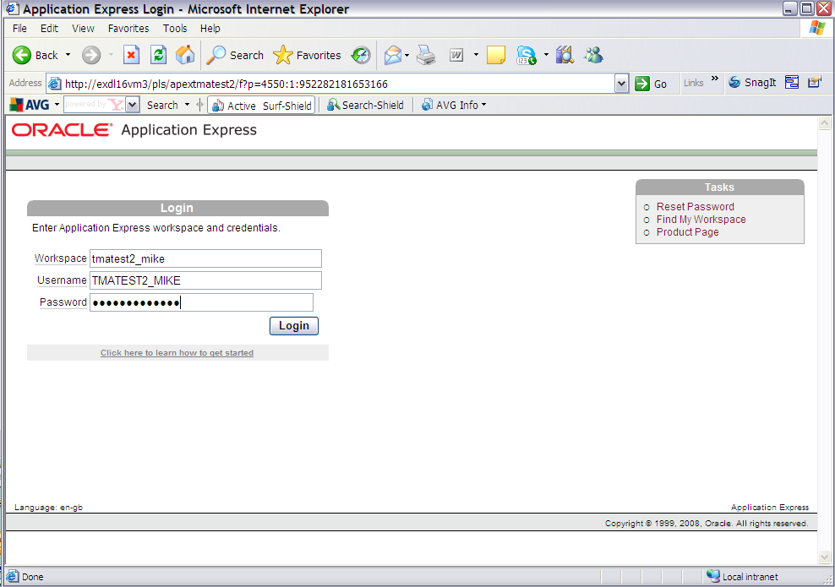

Select the 'Application Builder' option and import

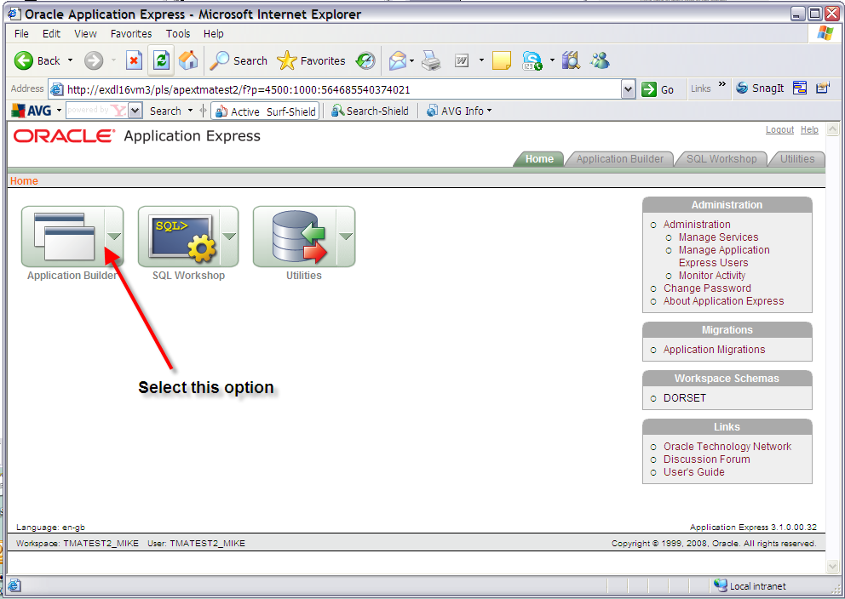

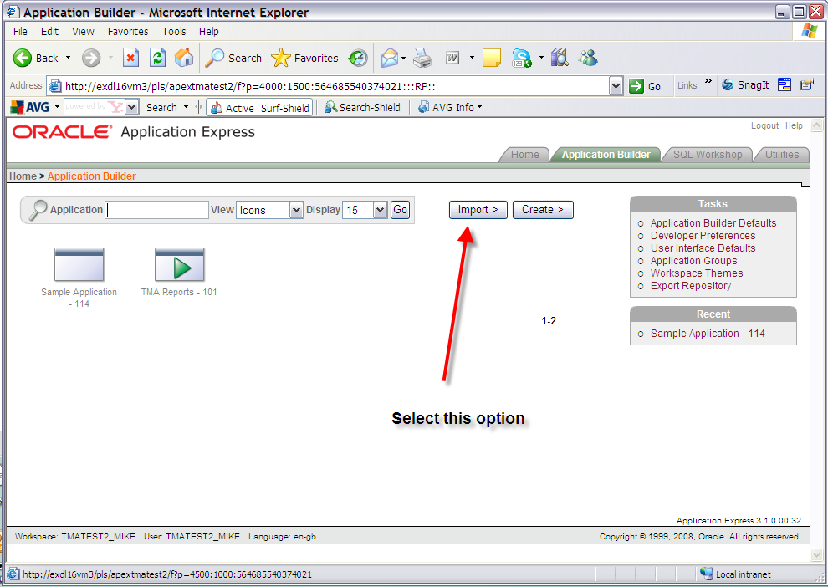

Import the ApEx Reports file under the directory <exor_base>\tma\admin\sql\tma_apex_rpts.sql

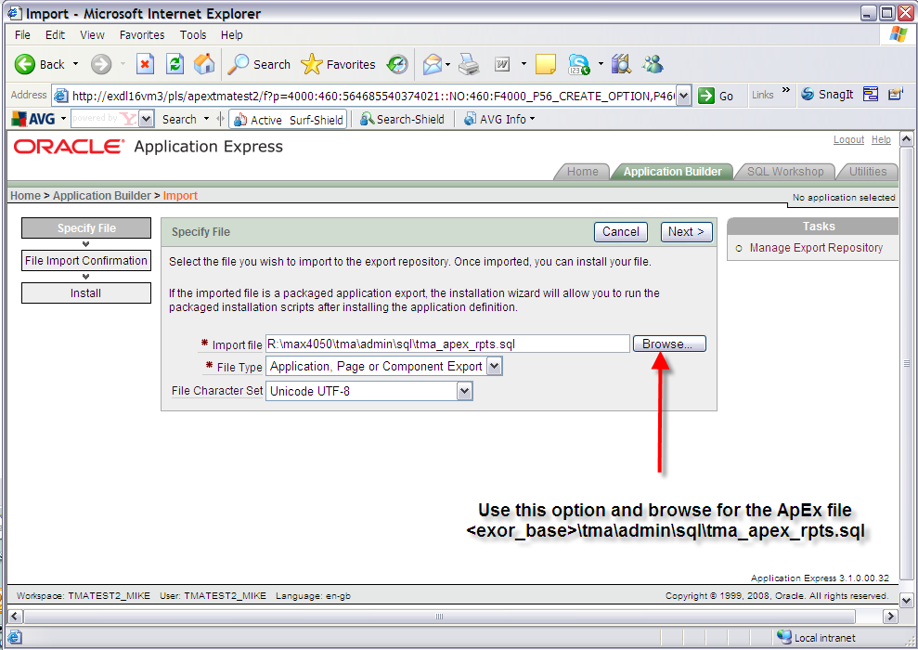

Once the file has been imported you will be met with this screen. Click the next button to proceed.

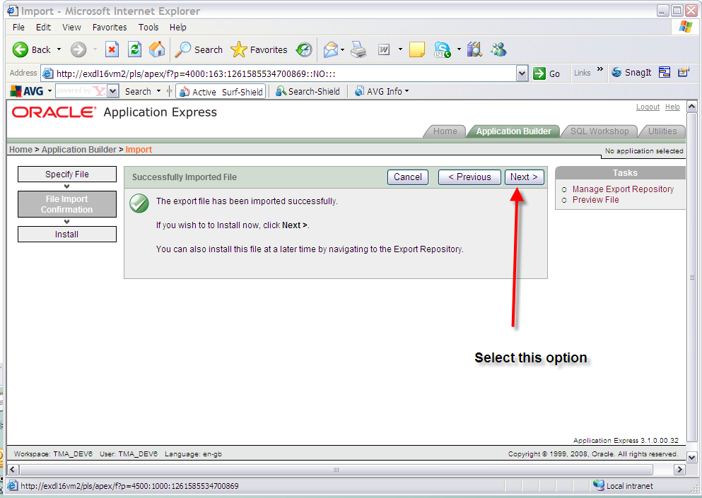

On the install application screen, which should be the screen presented, in the 'Install As Application' option select the 'Reuse Application ID 101 From Export' option and click the Install button. Parsing schema and build status should default values. Ensure that the Parsing Schema is the correct schema and the build status is ‘Run Application Only’.

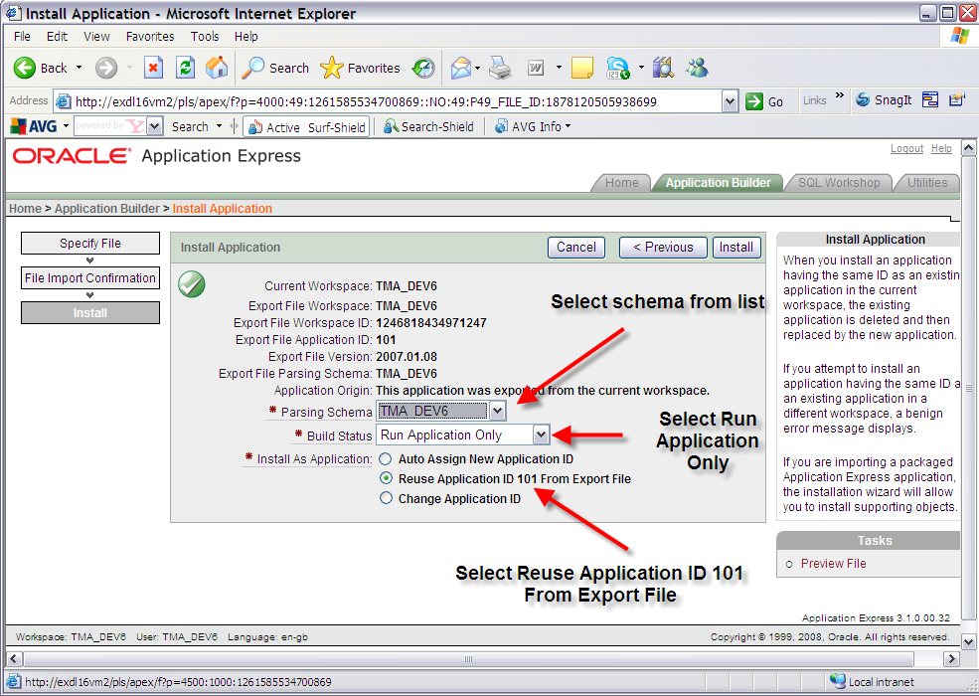

Click the Install button:

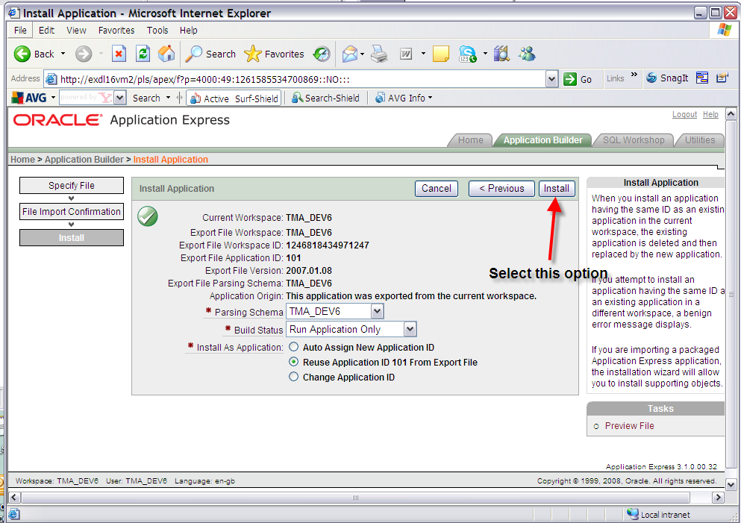

You should be presented with a 'Confirm Replace Application' screen. Click the 'Replace Existing Application' button.

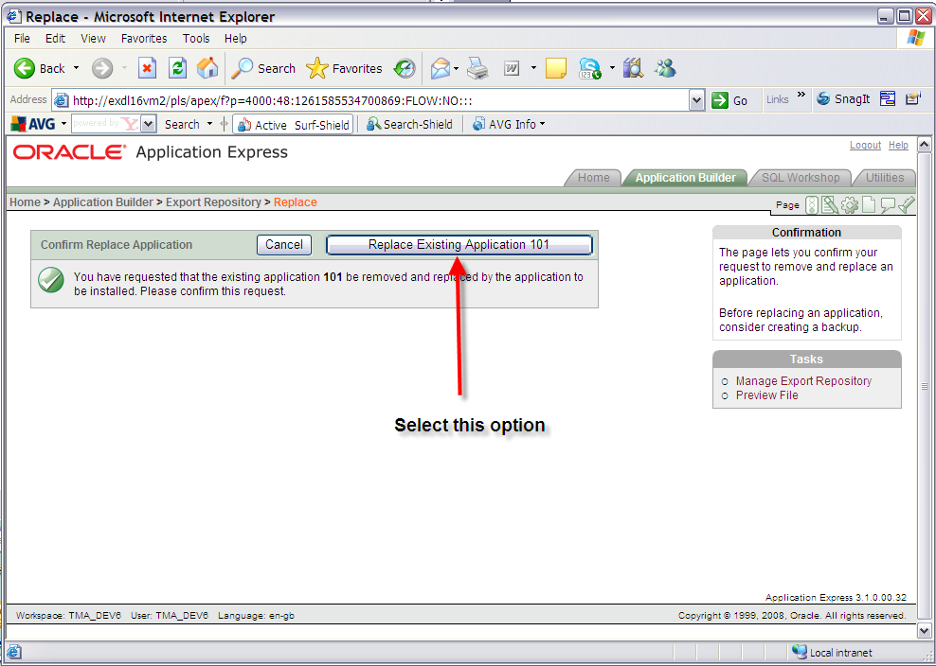

Exit the window which should read 'Application not available for edit'.

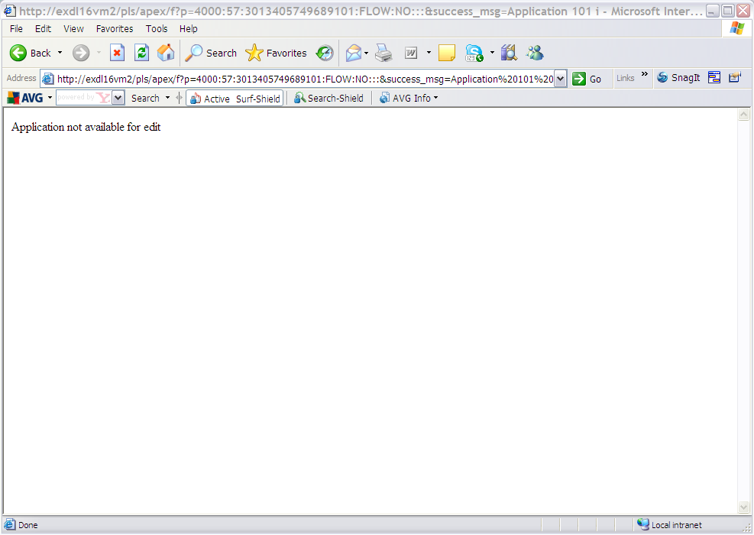

Test the reports from the TMA application.

- TMA API
  - Implementation of the TMA API Software files

To install the software components for TMA Manager execute the setup_tma_api_4050.exe and follow the on-screen prompts.

Extremely Important:

This is a patch release to be installed on top of release 4.0.4.6

It is crucial that when selecting the ‘Destination Folder’, you select that directory under which the existing 4.0.4.6 software resides.

When the wizard completes, the necessary client and server software files will have been installed.

Notes:
A password is required to be entered during this process. If you are not sure of the password contact support@exorcorp.com.

  - TMA API Server Upgrade
This chapter provides details of steps involved in upgrading the server components for TMA Manager.

Important:
This product will require upgrading after Network Manager, Street Gazetteer Manager and TMA Manager.

    - Before you Start

Before proceeding please ensure that the pre-requisites mentioned in Section 2.3 of this document are met.

Also, please be aware of the following;

Where instructed to change to a directory before running a script, it is assumed that you are running SQL*PLUS from a DOS Command prompt.

If you are running SQL*PLUS in windows you should set the 'start in' directory of the SQL*PLUS shortcut to simulate the change of directory.

If you do not run SQL*PLUS from the directory stated in each step of the guide, the installation will fail.

Also, whilst following the instructions in this section you will be required to know the location of <exor_base>. You may recall that whilst undertaking the tasks in Section 6.1 you will have implemented software into the location referred to as <exor_base>, for example, C:\EXOR.

    - Typical problems that you may encounter

It is possible that, when you are running some of the upgrade scripts, errors may be reported saying that objects already exist in the database or that columns already exist on tables. These errors can generally be ignored. If you are in any doubt, please contact the Exor support desk for guidance.

The upgrade procedures will also attempt to install database roles in the highways owner account that are necessary for the system to operate correctly. You may find that errors are produced when running the upgrade scripts to the effect that the role names being created are already used by existing roles or users. These errors can be ignored as they simply mean that the roles being created already exist.

Also during upgrade Warning messages may appear saying that compilation errors have occurred. These warnings can be ignored, since invalid objects will be recompiled prompt later on in the upgrade. However it will be of concern if compilation errors still occur following the re-compilation.

  - TMA External Notice API Implementation
    - Deployment of API Software Files

This section provides details of steps involved in deploying the files that the api is composed of to the relevant location on the file system.

Important:
All Exor applications that you install must go into the same destination – what is often referred to as <exor_base>.

To deploy the software components for the api, execute the setup_tma_api.exe and follow the on-screen prompts.

When the wizard completes, the necessary software files will have been deployed. These are held in the API directory. Copy the API folder and contents to the tma\admin folder.

    - API Server Component Install

This section provides details of steps involved in installing the server components for api.

Note, that there is no upgrade option; the software can be reinstalled as required.

Important:
The api will require installing after the TMA application.

Also please be aware of the following;

Where instructed to change to a directory before running a script, it is assumed that you are running SQL*PLUS from a DOS Command prompt.

If you are running SQL*PLUS in windows you should set the 'start in' directory of the SQL*PLUS shortcut to simulate the change of directory.

If you do not run SQL*PLUS from the directory stated in each step of the guide, the installation will fail.

Also, whilst following the instructions in this section you will be required to know the location of <exor_base>.

To create the base data and objects for api;

Change directory to <exor_base>\tma\admin\api

Login to SQL*PLUS as the highways owner on the client PC and run the following command

start tma_api_inst.sql

You will be prompted to enter the path of the location of your highways software. This should be name of the directory, including disk identifier and a trailing slash character, referred to as <exor_base>.

For example, if you installed your highways software in a directory called EXOR on your C drive, you would enter the following when prompted.

C:\EXOR\

When you have supplied this value, you will be prompted to confirm that it is correct and asked whether you wish to continue.

If the value specified is not correct or does not end with a slash character, you will be given an error message and the installation script will abort. You will then need to login to SQL*PLUS again and rerun the script.

When the script has completed, the api will have been installed.

Checking Log File(s)

The following log file is produced in the working directory. At the end of the installation, the file can be viewed to check for any errors that could have occurred during installation.

tma_api_install_<date&time>.LOG

Note:
If there are any queries regarding the results of the install then the Log file should be emailed to support@exorcorp.com to allow Exor support staff to verify the install has been successful.

- Streetworks Manager
  - Implementation of the Streetworks Manager Software files

To install the software components for TMA Manager execute the setup_streetworks_manager_4050.exe and follow the on-screen prompts.

When the wizard completes, the necessary client and server software files will have been installed.

Notes:
A password is required to be entered during this process. If you are not sure of the password contact support@exorcorp.com.

Important:
All exor applications that you install must go into the same destination – what is often referred to as <exor_base>.

To support different roll-out models, you can decide to just install Client or Server or both sets of components into the <exor_base>.

  - Streetworks Manager Server Upgrade
This chapter provides details of steps involved in upgrading the server components for Streetworks Manager.

Important:
This product will require upgrading after Network Manager and Street Gazetteer Manager.

    - Before you Start

Before proceeding please ensure that the pre-requisites mentioned in Section 2.3 of this document are met.

Also, please be aware of the following;

Where instructed to change to a directory before running a script, it is assumed that you are running SQL*PLUS from a DOS Command prompt.

If you are running SQL*PLUS in windows you should set the 'start in' directory of the SQL*PLUS shortcut to simulate the change of directory.

If you do not run SQL*PLUS from the directory stated in each step of the guide, the installation will fail.

Also, whilst following the instructions in this section you will be required to know the location of <exor_base>. You may recall that whilst undertaking the tasks in Section 7.1 you will have implemented software into the location referred to as <exor_base>, for example, C:\EXOR.

    - Typical problems that you may encounter

It is possible that, when you are running some of the upgrade scripts, errors may be reported saying that objects already exist in the database or that columns already exist on tables. These errors can generally be ignored. If you are in any doubt, please contact the Exor support desk for guidance.

The upgrade procedures will also attempt to install database roles in the highways owner account that are necessary for the system to operate correctly. You may find that errors are produced when running the upgrade scripts to the effect that the role names being created are already used by existing roles or users. These errors can be ignored as they simply mean that the roles being created already exist.

Also during upgrade Warning messages may appear saying that compilation errors have occurred. These warnings can be ignored, since invalid objects will be recompiled prompt later on in the upgrade. However it will be of concern if compilation errors still occur following the re-compilation.

    - Upgrade of Streetworks Manager

This section describes the steps necessary to upgrade Streetworks Manager to 4.0.5.0

Important
The server upgrade relies on invoking scripts shipped with the previous release. Therefore it is essential that the software was installed into the correct destination folder, as instructed in the previous chapter.

To upgrade the base data and objects for the Streetworks Manager modules;

- Change directory to <exor_base>\swr\install

- Login to SQL*PLUS as the highways owner on the client PC

- The same script is used to upgrade from the previous version shown in Section 2.2.
Run the following command

start swr4040_swr4050.sql

- You will be prompted to enter the path of the location of your highways software. This should be name of the directory, including disk identifier and a trailing slash character, referred to as <exor_base>.

For example, if you installed your highways software in a directory called EXOR on your C drive, you would enter the following when prompted.

C:\EXOR\

- When you have supplied this value, you will be prompted to confirm that it is correct and asked whether you wish to continue.

- If the value specified is not correct or does not end with a slash character, you will be given an error message and the installation script will abort. You will then need to login to SQL*PLUS again and rerun the script.

- When the script has completed, all the Streetworks Manager objects and data will have been upgraded.

Checking Log File(s)

The following log files are produced in the working directory. At the end of the upgrade, they can be viewed to check for any errors that could have occurred during the upgrade process.

swr4040_swr4050_1_<date&time>.LOG
swr4040_swr4050_2_<date&time>.LOG

Log files should be emailed to support@exorcorp.com to allow exor support staff to verify the upgrade has been successful.

Due to interdependencies between some Exor products, please ignore all compilation errors until all of your products have been upgraded.

    - Mandatory Configuration

exor_version.txt

Before accessing Streetworks Manager you must check the file exor_version.txt.

This file is referenced in Windows Registry setting ‘EXOR_VERSION’ and by default can be located in the <exor_base>\bin directory.

Ensure that the entry for Streetworks Manager is set accordingly;

SWR=4.0.5.0

    - Additional Configuration

Consult the documentation that accompanies this release for details of any additional configuration that may be required following an upgrade.

For example, to obtain details of product options, and for details of new product features/amendments.

Important:
It is highly recommended that you do this before attempting to use the application.

    - Spatial Configuration

Specific information regarding the registration of spatial layers can be found in the “Locator and Web Mapping” document.

- Maintenance Manager
  - Implementation of the Maintenance Manager Software files

To install the software components for Maintenance Manager execute the setup_maintenance_manager_4050.exe and follow the on-screen prompts.

When the wizard completes, the necessary client and server software files will have been installed.

Notes:
A password is required to be entered during this process. If you are not sure of the password contact support@exorcorp.com.

Important:
All exor applications that you install must go into the same destination – what is often referred to as <exor_base>.

To support different roll-out models, you can decide to just install Client or Server or both sets of components into the <exor_base>.

  - Maintenance Manager Server Upgrade
This chapter provides details of steps involved in upgrading the server components for Maintenance Manager.

Important:
This product will require upgrading after Network Manager.

    - Before you Start

Before proceeding please ensure that the pre-requisites mentioned in Section 2.3 of this document are met.

Also, please be aware of the following;

Where instructed to change to a directory before running a script, it is assumed that you are running SQL*PLUS from a DOS Command prompt.

If you are running SQL*PLUS in windows you should set the 'start in' directory of the SQL*PLUS shortcut to simulate the change of directory.

If you do not run SQL*PLUS from the directory stated in each step of the guide, the installation will fail.

Also, whilst following the instructions in this section you will be required to know the location of <exor_base>. You may recall that whilst undertaking the tasks in Section 8.1 you will have implemented software into the location referred to as <exor_base>, for example, C:\EXOR.

    - Typical problems that you may encounter

It is possible that, when you are running some of the upgrade scripts, errors may be reported saying that objects already exist in the database or that columns already exist on tables. These errors can generally be ignored. If you are in any doubt, please contact the Exor support desk for guidance.

The upgrade procedures will also attempt to install database roles in the highways owner account that are necessary for the system to operate correctly. You may find that errors are produced when running the upgrade scripts to the effect that the role names being created are already used by existing roles or users. These errors can be ignored as they simply mean that the roles being created already exist.

Also during upgrade Warning messages may appear saying that compilation errors have occurred. These warnings can be ignored, since invalid objects will be recompiled prompt later on in the upgrade. However it will be of concern if compilation errors still occur following the re-compilation.

    - Upgrade of Maintenance Manager

This section describes the steps necessary to upgrade Maintenance Manager to 4.0.5.0 (from 4.0.4.0 or 4.0.4.3)

Important
The server upgrade relies on invoking scripts shipped with the previous release. Therefore it is essential that the software was installed into the correct destination folder, as instructed in the previous chapter.

To upgrade the base data and objects for the Maintenance Manager modules;

- Change directory to <exor_base>\mai\install

- Login to SQL*PLUS as the highways owner on the client PC

- The same script is used to upgrade from the previous version shown in Section 2.2.
Run the following command

start mai4040_mai4050.sql

- You will be prompted to enter the path of the location of your highways software. This should be name of the directory, including disk identifier and a trailing slash character, referred to as <exor_base>.

For example, if you installed your highways software in a directory called EXOR on your C drive, you would enter the following when prompted.

C:\EXOR\

- When you have supplied this value, you will be prompted to confirm that it is correct and asked whether you wish to continue.

- If the value specified is not correct or does not end with a slash character, you will be given an error message and the installation script will abort. You will then need to login to SQL*PLUS again and rerun the script.

- When the script has completed, all the Maintenance Manager objects and data will have been upgraded.

Checking Log File(s)

The following log files are produced in the working directory. At the end of the upgrade, they can be viewed to check for any errors that could have occurred during the upgrade process.

mai404x_mai4050_1_<date&time>.LOG
mai404x_mai4050_2_<date&time>.LOG

Log files should be emailed to support@exorcorp.com to allow exor support staff to verify the upgrade has been successful.

Due to interdependencies between some Exor products, please ignore all compilation errors until all of your products have been upgraded.

    - Mandatory Configuration

exor_version.txt

Before accessing Maintenance Manager you must check the file exor_version.txt.

This file is referenced in Windows Registry setting ‘EXOR_VERSION’ and by default can be located in the <exor_base>\bin directory.

Ensure that the entry for Maintenance Manager is set accordingly;

MAI=4.0.5.0

    - Additional Configuration

Consult the documentation that accompanies this release for details of any additional configuration that may be required following an upgrade.

For example, to obtain details of product options, and for details of new product features/amendments.

Important:
It is highly recommended that you do this before attempting to use the application.

    - Spatial Configuration

Specific information regarding the registration of spatial layers can be found in the “Locator and Web Mapping” document.

- Public Enquiry Manager
  - Implementation of the Public Enquiry Manager Software files

To install the software components for Public Enquiry Manager execute the setup_public_enquiry_manager_4050.exe and follow the on-screen prompts.

When the wizard completes, the necessary client and server software files will have been installed.

Notes:
A password is required to be entered during this process. If you are not sure of the password contact support@exorcorp.com.

Important:
All exor applications that you install must go into the same destination – what is often referred to as <exor_base>.

To support different roll-out models, you can decide to just install Client or Server or both sets of components into the <exor_base>.

  - Public Enquiry Manager Server Upgrade
This chapter provides details of steps involved in upgrading the server components for Public Enquiry Manager.

Important:
This product will require upgrading after Network Manager and Maintenance Manager.

    - Before you Start

Before proceeding please ensure that the pre-requisites mentioned in Section 2.3 of this document are met.

Also, please be aware of the following;

Where instructed to change to a directory before running a script, it is assumed that you are running SQL*PLUS from a DOS Command prompt.

If you are running SQL*PLUS in windows you should set the 'start in' directory of the SQL*PLUS shortcut to simulate the change of directory.

If you do not run SQL*PLUS from the directory stated in each step of the guide, the installation will fail.

Also, whilst following the instructions in this section you will be required to know the location of <exor_base>. You may recall that whilst undertaking the tasks in Section 9.1 you will have implemented software into the location referred to as <exor_base>, for example, C:\EXOR.

    - Typical problems that you may encounter

It is possible that, when you are running some of the upgrade scripts, errors may be reported saying that objects already exist in the database or that columns already exist on tables. These errors can generally be ignored. If you are in any doubt, please contact the Exor support desk for guidance.

The upgrade procedures will also attempt to install database roles in the highways owner account that are necessary for the system to operate correctly. You may find that errors are produced when running the upgrade scripts to the effect that the role names being created are already used by existing roles or users. These errors can be ignored as they simply mean that the roles being created already exist.

Also during upgrade Warning messages may appear saying that compilation errors have occurred. These warnings can be ignored, since invalid objects will be recompiled prompt later on in the upgrade. However it will be of concern if compilation errors still occur following the re-compilation.

    - Upgrade of Public Enquiry Manager

This section describes the steps necessary to upgrade Public enquiry Manager to 4.0.5.0 (from 4.0.4.0 or 4.0.4.3)

Important
The server upgrade relies on invoking scripts shipped with the previous release. Therefore it is essential that the software was installed into the correct destination folder, as instructed in the previous chapter.

To upgrade the base data and objects for the Public enquiry Manager modules;

- Change directory to <exor_base>\pem\install

- Login to SQL*PLUS as the highways owner on the client PC

- The same script is used to upgrade from the previous version shown in Section 2.2.
Run the following command

start pem4040_pem4050.sql

- You will be prompted to enter the path of the location of your highways software. This should be name of the directory, including disk identifier and a trailing slash character, referred to as <exor_base>.

For example, if you installed your highways software in a directory called EXOR on your C drive, you would enter the following when prompted.

C:\EXOR\

- When you have supplied this value, you will be prompted to confirm that it is correct and asked whether you wish to continue.

- If the value specified is not correct or does not end with a slash character, you will be given an error message and the installation script will abort. You will then need to login to SQL*PLUS again and rerun the script.

- When the script has completed, all the Public enquiry Manager objects and data will have been upgraded.

Checking Log File(s)

The following log files are produced in the working directory. At the end of the upgrade, they can be viewed to check for any errors that could have occurred during the upgrade process.

pem404x_pem4050_1_<date&time>.LOG
pem404x_pem4050_2_<date&time>.LOG

Log files should be emailed to support@exorcorp.com to allow exor support staff to verify the upgrade has been successful.

Due to interdependencies between some Exor products, please ignore all compilation errors until all of your products have been upgraded.

    - Mandatory Configuration

exor_version.txt

Before accessing Public enquiry Manager you must check the file exor_version.txt.

This file is referenced in Windows Registry setting ‘EXOR_VERSION’ and by default can be located in the <exor_base>\bin directory.

Ensure that the entry for Public Enquiry Manager is set accordingly;

PEM=4.0.5.0

    - Additional Configuration

Consult the documentation that accompanies this release for details of any additional configuration that may be required following an upgrade.

For example, to obtain details of product options, and for details of new product features/amendments.

Important:
It is highly recommended that you do this before attempting to use the application.

    - Spatial Configuration

Specific information regarding the registration of spatial layers can be found in the “Locator and Web Mapping” document.

- Asset Valuation Manager
  - Implementation of the Asset Valuation Manager Software files

To install the software components for Asset Valuation Manager execute the setup_asset_valuation_manager_4050.exe and follow the on-screen prompts.

When the wizard completes, the necessary client and server software files will have been installed.

Notes:
A password is required to be entered during this process. If you are not sure of the password contact support@exorcorp.com.

Important:
All exor applications that you install must go into the same destination – what is often referred to as <exor_base>.

To support different roll-out models, you can decide to just install Client or Server or both sets of components into the <exor_base>.

  - Asset Valuation Manager Server Upgrade
This chapter provides details of steps involved in upgrading the server components for Asset Valuation Manager.

Important:
This product will require upgrading after Network Manager.

    - Before you Start

Before proceeding please ensure that the pre-requisites mentioned in Section 2.3 of this document are met.

Also, please be aware of the following;

Where instructed to change to a directory before running a script, it is assumed that you are running SQL*PLUS from a DOS Command prompt.

If you are running SQL*PLUS in windows you should set the 'start in' directory of the SQL*PLUS shortcut to simulate the change of directory.

If you do not run SQL*PLUS from the directory stated in each step of the guide, the installation will fail.

Also, whilst following the instructions in this section you will be required to know the location of <exor_base>. You may recall that whilst undertaking the tasks in Section 10.1 you will have implemented software into the location referred to as <exor_base>, for example, C:\EXOR.

    - Typical problems that you may encounter

It is possible that, when you are running some of the upgrade scripts, errors may be reported saying that objects already exist in the database or that columns already exist on tables. These errors can generally be ignored. If you are in any doubt, please contact the Exor support desk for guidance.

The upgrade procedures will also attempt to install database roles in the highways owner account that are necessary for the system to operate correctly. You may find that errors are produced when running the upgrade scripts to the effect that the role names being created are already used by existing roles or users. These errors can be ignored as they simply mean that the roles being created already exist.

Also during upgrade Warning messages may appear saying that compilation errors have occurred. These warnings can be ignored, since invalid objects will be recompiled prompt later on in the upgrade. However it will be of concern if compilation errors still occur following the re-compilation.

    - Upgrade of Asset Valuation Manager

This section describes the steps necessary to upgrade Asset Valuation Manager to 4.0.5.0

Important
The server upgrade relies on invoking scripts shipped with the previous release. Therefore it is essential that the software was installed into the correct destination folder, as instructed in the previous chapter.

To upgrade the base data and objects for the Asset Valuation Manager modules;

- Change directory to <exor_base>\avm\install

- Login to SQL*PLUS as the highways owner on the client PC

- The same script is used to upgrade from the previous version shown in Section 2.2.
Run the following command

start avm4040_avm4050.sql

- You will be prompted to enter the path of the location of your highways software. This should be name of the directory, including disk identifier and a trailing slash character, referred to as <exor_base>.

For example, if you installed your highways software in a directory called EXOR on your C drive, you would enter the following when prompted.

C:\EXOR\

- When you have supplied this value, you will be prompted to confirm that it is correct and asked whether you wish to continue.

- If the value specified is not correct or does not end with a slash character, you will be given an error message and the installation script will abort. You will then need to login to SQL*PLUS again and rerun the script.

- When the script has completed, all the Asset Valuation Manager objects and data will have been upgraded.

Checking Log File(s)

The following log files are produced in the working directory. At the end of the upgrade, they can be viewed to check for any errors that could have occurred during the upgrade process.

avm4040_avm4050_1_<date&time>.LOG
avm4040_avm4050_2_<date&time>.LOG

Log files should be emailed to support@exorcorp.com to allow exor support staff to verify the upgrade has been successful.

Due to interdependencies between some Exor products, please ignore all compilation errors until all of your products have been upgraded.

    - Mandatory Configuration

exor_version.txt

Before accessing Asset Valuation Manager you must check the file exor_version.txt.

This file is referenced in Windows Registry setting ‘EXOR_VERSION’ and by default can be located in the <exor_base>\bin directory.

Ensure that the entry for Asset Valuation Manager is set accordingly;

AVM=4.0.5.0

    - Additional Configuration

Consult the documentation that accompanies this release for details of any additional configuration that may be required following an upgrade.

For example, to obtain details of product options, and for details of new product features/amendments.

Important:
It is highly recommended that you do this before attempting to use the application.

    - Spatial Configuration

Specific information regarding the registration of spatial layers can be found in the “Locator and Web Mapping” document.
- Accidents Manager
  - Implementation of the Accidents Manager Software files

To install the software components for Accidents Manager execute the setup_accidents_manager_4050.exe and follow the on-screen prompts.

When the wizard completes, the necessary client and server software files will have been installed.

Notes:
A password is required to be entered during this process. If you are not sure of the password contact support@exorcorp.com.

Important:
All exor applications that you install must go into the same destination – what is often referred to as <exor_base>.

To support different roll-out models, you can decide to just install Client or Server or both sets of components into the <exor_base>.

  - Accidents Manager Server Upgrade
This chapter provides details of steps involved in upgrading the server components for Accidents Manager.

Important:
This product will require upgrading after Network Manager.

    - Before you Start

Before proceeding please ensure that the pre-requisites mentioned in Section 2.3 of this document are met.

Also, please be aware of the following;

Where instructed to change to a directory before running a script, it is assumed that you are running SQL*PLUS from a DOS Command prompt.

If you are running SQL*PLUS in windows you should set the 'start in' directory of the SQL*PLUS shortcut to simulate the change of directory.

If you do not run SQL*PLUS from the directory stated in each step of the guide, the installation will fail.

Also, whilst following the instructions in this section you will be required to know the location of <exor_base>. You may recall that whilst undertaking the tasks in Section 11.1 you will have implemented software into the location referred to as <exor_base>, for example, C:\EXOR.

    - Typical problems that you may encounter

It is possible that, when you are running some of the upgrade scripts, errors may be reported saying that objects already exist in the database or that columns already exist on tables. These errors can generally be ignored. If you are in any doubt, please contact the Exor support desk for guidance.

The upgrade procedures will also attempt to install database roles in the highways owner account that are necessary for the system to operate correctly. You may find that errors are produced when running the upgrade scripts to the effect that the role names being created are already used by existing roles or users. These errors can be ignored as they simply mean that the roles being created already exist.

Also during upgrade Warning messages may appear saying that compilation errors have occurred. These warnings can be ignored, since invalid objects will be recompiled prompt later on in the upgrade. However it will be of concern if compilation errors still occur following the re-compilation.

    - Upgrade of Accidents Manager

This section describes the steps necessary to upgrade Accidents Manager to 4.0.5.0

Important
The server upgrade relies on invoking scripts shipped with the previous release. Therefore it is essential that the software was installed into the correct destination folder, as instructed in the previous chapter.

To upgrade the base data and objects for the Accidents Manager modules;

- Change directory to <exor_base>\acc\install

- Login to SQL*PLUS as the highways owner on the client PC

- The same script is used to upgrade from the previous version shown in Section 2.2.
Run the following command

start acc4040_acc4050.sql

- You will be prompted to enter the path of the location of your highways software. This should be name of the directory, including disk identifier and a trailing slash character, referred to as <exor_base>.

For example, if you installed your highways software in a directory called EXOR on your C drive, you would enter the following when prompted.

C:\EXOR\

- When you have supplied this value, you will be prompted to confirm that it is correct and asked whether you wish to continue.

- If the value specified is not correct or does not end with a slash character, you will be given an error message and the installation script will abort. You will then need to login to SQL*PLUS again and rerun the script.

- When the script has completed, all the Accidents Manager objects and data will have been upgraded.

Checking Log File(s)

The following log files are produced in the working directory. At the end of the upgrade, they can be viewed to check for any errors that could have occurred during the upgrade process.

acc4040_acc4050_1_<date&time>.LOG
acc4040_acc4050_2_<date&time>.LOG

Log files should be emailed to support@exorcorp.com to allow exor support staff to verify the upgrade has been successful.

Due to interdependencies between some Exor products, please ignore all compilation errors until all of your products have been upgraded.

    - Mandatory Configuration

exor_version.txt

Before accessing Accidents Manager you must check the file exor_version.txt.

This file is referenced in Windows Registry setting ‘EXOR_VERSION’ and by default can be located in the <exor_base>\bin directory.

Ensure that the entry for Accidents Manager is set accordingly;

ACC=4.0.5.0

    - Additional Configuration

Consult the documentation that accompanies this release for details of any additional configuration that may be required following an upgrade.

For example, to obtain details of product options, and for details of new product features/amendments.

Important:
It is highly recommended that you do this before attempting to use the application.

    - Spatial Configuration

Specific information regarding the registration of spatial layers can be found in the “Locator and Web Mapping” document.
- Public Rights Of Way Manager
  - Implementation of the Public Rights Of Way Manager Software files

To install the software components for Public Rights Of Way Manager execute the setup_public_rights_of_way_manager_4050.exe and follow the on-screen prompts.

When the wizard completes, the necessary client and server software files will have been installed.

Notes:
A password is required to be entered during this process. If you are not sure of the password contact support@exorcorp.com.

Important:
All exor applications that you install must go into the same destination – what is often referred to as <exor_base>.

To support different roll-out models, you can decide to just install Client or Server or both sets of components into the <exor_base>.

  - Public Rights Of Way Manager Server Upgrade
This chapter provides details of steps involved in upgrading the server components for Public Rights Of Way Manager.

Important:
This product will require upgrading after Network Manager.

This product also has dependencies on Public Enquiry Manager, Asset Valuation Manager and Maintenance Manager so they must be installed/upgraded before you begin this upgrade.

    - Before you Start

Before proceeding please ensure that the pre-requisites mentioned in Section 2.3 of this document are met.

Also, please be aware of the following;

Where instructed to change to a directory before running a script, it is assumed that you are running SQL*PLUS from a DOS Command prompt.

If you are running SQL*PLUS in windows you should set the 'start in' directory of the SQL*PLUS shortcut to simulate the change of directory.

If you do not run SQL*PLUS from the directory stated in each step of the guide, the installation will fail.

Also, whilst following the instructions in this section you will be required to know the location of <exor_base>. You may recall that whilst undertaking the tasks in Section 12.1 you will have implemented software into the location referred to as <exor_base>, for example, C:\EXOR.

    - Typical problems that you may encounter

It is possible that, when you are running some of the upgrade scripts, errors may be reported saying that objects already exist in the database or that columns already exist on tables. These errors can generally be ignored. If you are in any doubt, please contact the Exor support desk for guidance.

The upgrade procedures will also attempt to install database roles in the highways owner account that are necessary for the system to operate correctly. You may find that errors are produced when running the upgrade scripts to the effect that the role names being created are already used by existing roles or users. These errors can be ignored as they simply mean that the roles being created already exist.

Also during upgrade Warning messages may appear saying that compilation errors have occurred. These warnings can be ignored, since invalid objects will be recompiled prompt later on in the upgrade. However it will be of concern if compilation errors still occur following the re-compilation.

    - Upgrade of Public Rights Of Way Manager

This section describes the steps necessary to upgrade Public Rights Of Way Manager to 4.0.5.0

Important
The server upgrade relies on invoking scripts shipped with the previous release. Therefore it is essential that the software was installed into the correct destination folder, as instructed in the previous chapter.

To upgrade the base data and objects for the Public Rights Of Way Manager modules;

- Change directory to <exor_base>\prow\install

- Login to SQL*PLUS as the highways owner on the client PC

- The same script is used to upgrade from the previous version shown in Section 2.2.
Run the following command

start prow4040_prow4050.sql

- You will be prompted to enter the path of the location of your highways software. This should be name of the directory, including disk identifier and a trailing slash character, referred to as <exor_base>.

For example, if you installed your highways software in a directory called EXOR on your C drive, you would enter the following when prompted.

C:\EXOR\

- When you have supplied this value, you will be prompted to confirm that it is correct and asked whether you wish to continue.

- If the value specified is not correct or does not end with a slash character, you will be given an error message and the installation script will abort. You will then need to login to SQL*PLUS again and rerun the script.

- When the script has completed, all the Public Rights Of Way Manager objects and data will have been upgraded.

Checking Log File(s)

The following log files are produced in the working directory. At the end of the upgrade, they can be viewed to check for any errors that could have occurred during the upgrade process.

prow4040_prow4050_1_<date&time>.LOG
prow4040_prow4050_2_<date&time>.LOG

Log files should be emailed to support@exorcorp.com to allow exor support staff to verify the upgrade has been successful.

Due to interdependencies between some Exor products, please ignore all compilation errors until all of your products have been upgraded.

    - Mandatory Configuration

exor_version.txt

Before accessing Public Rights Of Way Manager you must check the file exor_version.txt.

This file is referenced in Windows Registry setting ‘EXOR_VERSION’ and by default can be located in the <exor_base>\bin directory.

Ensure that the entry for Public Rights Of Way Manager is set accordingly;

PROW=4.0.5.0

    - Additional Configuration

Consult the documentation that accompanies this release for details of any additional configuration that may be required following an upgrade.

For example, to obtain details of product options, and for details of new product features/amendments.

Important:
It is highly recommended that you do this before attempting to use the application.

    - Spatial Configuration

Specific information regarding the registration of spatial layers can be found in the “Locator and Web Mapping” document.

- Street Lighting Manager
  - Implementation of the Street Lighting Manager Software files

To install the software components for Street Lighting Manager execute the setup_street_lighting_manager_4050.exe and follow the on-screen prompts.

When the wizard completes, the necessary client and server software files will have been installed.

Notes:
A password is required to be entered during this process. If you are not sure of the password contact support@exorcorp.com.

Important:
All exor applications that you install must go into the same destination – what is often referred to as <exor_base>.

To support different roll-out models, you can decide to just install Client or Server or both sets of components into the <exor_base>.

  - Street Lighting Manager Server Upgrade
This chapter provides details of steps involved in upgrading the server components for Street Lighting Manager.

Important:
This product will require upgrading after Network Manager.

    - Before you Start

Before proceeding please ensure that the pre-requisites mentioned in Section 2.3 of this document are met.

Also, please be aware of the following;

Where instructed to change to a directory before running a script, it is assumed that you are running SQL*PLUS from a DOS Command prompt.

If you are running SQL*PLUS in windows you should set the 'start in' directory of the SQL*PLUS shortcut to simulate the change of directory.

If you do not run SQL*PLUS from the directory stated in each step of the guide, the installation will fail.

Also, whilst following the instructions in this section you will be required to know the location of <exor_base>. You may recall that whilst undertaking the tasks in Section 13.1 you will have implemented software into the location referred to as <exor_base>, for example, C:\EXOR.

    - Typical problems that you may encounter

It is possible that, when you are running some of the upgrade scripts, errors may be reported saying that objects already exist in the database or that columns already exist on tables. These errors can generally be ignored. If you are in any doubt, please contact the Exor support desk for guidance.

The upgrade procedures will also attempt to install database roles in the highways owner account that are necessary for the system to operate correctly. You may find that errors are produced when running the upgrade scripts to the effect that the role names being created are already used by existing roles or users. These errors can be ignored as they simply mean that the roles being created already exist.

Also during upgrade Warning messages may appear saying that compilation errors have occurred. These warnings can be ignored, since invalid objects will be recompiled prompt later on in the upgrade. However it will be of concern if compilation errors still occur following the re-compilation.

    - Upgrade of Street Lighting Manager

This section describes the steps necessary to upgrade Street Lighting Manager to 4.0.5.0

Important
The server upgrade relies on invoking scripts shipped with the previous release. Therefore it is essential that the software was installed into the correct destination folder, as instructed in the previous chapter.

To upgrade the base data and objects for the Street Lighting Manager modules;

- Change directory to <exor_base>\slm\install

- Login to SQL*PLUS as the highways owner on the client PC

- The same script is used to upgrade from the previous version shown in Section 2.2.
Run the following command

start slm4040_slm4050.sql

- You will be prompted to enter the path of the location of your highways software. This should be name of the directory, including disk identifier and a trailing slash character, referred to as <exor_base>.

For example, if you installed your highways software in a directory called EXOR on your C drive, you would enter the following when prompted.

C:\EXOR\

- When you have supplied this value, you will be prompted to confirm that it is correct and asked whether you wish to continue.

- If the value specified is not correct or does not end with a slash character, you will be given an error message and the installation script will abort. You will then need to login to SQL*PLUS again and rerun the script.

- When the script has completed, all the Street Lighting Manager objects and data will have been upgraded.

Checking Log File(s)

The following log files are produced in the working directory. At the end of the upgrade, they can be viewed to check for any errors that could have occurred during the upgrade process.

slm4040_slm4050_1_<date&time>.LOG
slm4040_slm4050_2_<date&time>.LOG

Log files should be emailed to support@exorcorp.com to allow exor support staff to verify the upgrade has been successful.

Due to interdependencies between some Exor products, please ignore all compilation errors until all of your products have been upgraded.

    - Mandatory Configuration

exor_version.txt

Before accessing Street Lighting Manager you must check the file exor_version.txt.

This file is referenced in Windows Registry setting ‘EXOR_VERSION’ and by default can be located in the <exor_base>\bin directory.

Ensure that the entry for Street Lighting Manager is set accordingly;

CLM=4.0.5.0

    - Additional Configuration

Consult the documentation that accompanies this release for details of any additional configuration that may be required following an upgrade.

For example, to obtain details of product options, and for details of new product features/amendments.

Important:
It is highly recommended that you do this before attempting to use the application.

    - Spatial Configuration

Specific information regarding the registration of spatial layers can be found in the “Locator and Web Mapping” document.
- Schemes Manager
  - Implementation of the Schemes Manager Software files

To install the software components for Schemes Manager execute the setup_schemes_manager_4050.exe and follow the on-screen prompts.

When the wizard completes, the necessary client and server software files will have been installed.

Notes:
A password is required to be entered during this process. If you are not sure of the password contact support@exorcorp.com.

Important:
All exor applications that you install must go into the same destination – what is often referred to as <exor_base>.

To support different roll-out models, you can decide to just install Client or Server or both sets of components into the <exor_base>.

  - Schemes Manager Server Upgrade
This chapter provides details of steps involved in upgrading the server components for Schemes Manager.

Important:
This product will require upgrading after Network Manager.

    - Before you Start

Before proceeding please ensure that the pre-requisites mentioned in Section 2.3 of this document are met.

Also, please be aware of the following;

Where instructed to change to a directory before running a script, it is assumed that you are running SQL*PLUS from a DOS Command prompt.

If you are running SQL*PLUS in windows you should set the 'start in' directory of the SQL*PLUS shortcut to simulate the change of directory.

If you do not run SQL*PLUS from the directory stated in each step of the guide, the installation will fail.

Also, whilst following the instructions in this section you will be required to know the location of <exor_base>. You may recall that whilst undertaking the tasks in Section 14.1 you will have implemented software into the location referred to as <exor_base>, for example, C:\EXOR.

    - Typical problems that you may encounter

It is possible that, when you are running some of the upgrade scripts, errors may be reported saying that objects already exist in the database or that columns already exist on tables. These errors can generally be ignored. If you are in any doubt, please contact the Exor support desk for guidance.

The upgrade procedures will also attempt to install database roles in the highways owner account that are necessary for the system to operate correctly. You may find that errors are produced when running the upgrade scripts to the effect that the role names being created are already used by existing roles or users. These errors can be ignored as they simply mean that the roles being created already exist.

Also during upgrade Warning messages may appear saying that compilation errors have occurred. These warnings can be ignored, since invalid objects will be recompiled prompt later on in the upgrade. However it will be of concern if compilation errors still occur following the re-compilation.

    - Upgrade of Schemes Manager

This section describes the steps necessary to upgrade Schemes Manager to 4.0.5.0

Important
The server upgrade relies on invoking scripts shipped with the previous release. Therefore it is essential that the software was installed into the correct destination folder, as instructed in the previous chapter.

To upgrade the base data and objects for the Schemes Manager modules;

- Change directory to <exor_base>\stp\install

- Login to SQL*PLUS as the highways owner on the client PC

- The same script is used to upgrade from the previous version shown in Section 2.2.
Run the following command

start stp4040_stp4050.sql

- You will be prompted to enter the path of the location of your highways software. This should be name of the directory, including disk identifier and a trailing slash character, referred to as <exor_base>.

For example, if you installed your highways software in a directory called EXOR on your C drive, you would enter the following when prompted.

C:\EXOR\

- When you have supplied this value, you will be prompted to confirm that it is correct and asked whether you wish to continue.

- If the value specified is not correct or does not end with a slash character, you will be given an error message and the installation script will abort. You will then need to login to SQL*PLUS again and rerun the script.

- When the script has completed, all the Schemes Manager objects and data will have been upgraded.

Checking Log File(s)

The following log files are produced in the working directory. At the end of the upgrade, they can be viewed to check for any errors that could have occurred during the upgrade process.

stp4040_stp4050_1_<date&time>.LOG
stp4040_stp4050_2_<date&time>.LOG

Log files should be emailed to support@exorcorp.com to allow exor support staff to verify the upgrade has been successful.

Due to interdependencies between some Exor products, please ignore all compilation errors until all of your products have been upgraded.

    - Mandatory Configuration

exor_version.txt

Before accessing Schemes Manager you must check the file exor_version.txt.

This file is referenced in Windows Registry setting ‘EXOR_VERSION’ and by default can be located in the <exor_base>\bin directory.

Ensure that the entry for Schemes Manager is set accordingly;

STP=4.0.5.0

    - Additional Configuration

Consult the documentation that accompanies this release for details of any additional configuration that may be required following an upgrade.

For example, to obtain details of product options, and for details of new product features/amendments.

Important:
It is highly recommended that you do this before attempting to use the application.

    - Spatial Configuration

Specific information regarding the registration of spatial layers can be found in the “Locator and Web Mapping” document.
- Structures Manager
  - Implementation of the Structures Manager Software files

To install the software components for Structures Manager execute the setup_structures_manager_4050.exe and follow the on-screen prompts.

When the wizard completes, the necessary client and server software files will have been installed.

Notes:
A password is required to be entered during this process. If you are not sure of the password contact support@exorcorp.com.

Important:
All exor applications that you install must go into the same destination – what is often referred to as <exor_base>.

To support different roll-out models, you can decide to just install Client or Server or both sets of components into the <exor_base>.

  - Structures Manager Server Upgrade
This chapter provides details of steps involved in upgrading the server components for Structures Manager.

Important:
This product will require upgrading after Network Manager.

    - Before you Start

Before proceeding please ensure that the pre-requisites mentioned in Section 2.3 of this document are met.

Also, please be aware of the following;

Where instructed to change to a directory before running a script, it is assumed that you are running SQL*PLUS from a DOS Command prompt.

If you are running SQL*PLUS in windows you should set the 'start in' directory of the SQL*PLUS shortcut to simulate the change of directory.

If you do not run SQL*PLUS from the directory stated in each step of the guide, the installation will fail.

Also, whilst following the instructions in this section you will be required to know the location of <exor_base>. You may recall that whilst undertaking the tasks in Section 15.1 you will have implemented software into the location referred to as <exor_base>, for example, C:\EXOR.

    - Typical problems that you may encounter

It is possible that, when you are running some of the upgrade scripts, errors may be reported saying that objects already exist in the database or that columns already exist on tables. These errors can generally be ignored. If you are in any doubt, please contact the Exor support desk for guidance.

The upgrade procedures will also attempt to install database roles in the highways owner account that are necessary for the system to operate correctly. You may find that errors are produced when running the upgrade scripts to the effect that the role names being created are already used by existing roles or users. These errors can be ignored as they simply mean that the roles being created already exist.

Also during upgrade Warning messages may appear saying that compilation errors have occurred. These warnings can be ignored, since invalid objects will be recompiled prompt later on in the upgrade. However it will be of concern if compilation errors still occur following the re-compilation.

    - Upgrade of Structures Manager

This section describes the steps necessary to upgrade Structures Manager to 4.0.5.0

Important
The server upgrade relies on invoking scripts shipped with the previous release. Therefore it is essential that the software was installed into the correct destination folder, as instructed in the previous chapter.

To upgrade the base data and objects for the Structures Manager modules;

- Change directory to <exor_base>\str\install

- Login to SQL*PLUS as the highways owner on the client PC

- The same script is used to upgrade from the previous version shown in Section 2.2.
Run the following command

start str4040_str4050.sql

- You will be prompted to enter the path of the location of your highways software. This should be name of the directory, including disk identifier and a trailing slash character, referred to as <exor_base>.

For example, if you installed your highways software in a directory called EXOR on your C drive, you would enter the following when prompted.

C:\EXOR\

- When you have supplied this value, you will be prompted to confirm that it is correct and asked whether you wish to continue.

- If the value specified is not correct or does not end with a slash character, you will be given an error message and the installation script will abort. You will then need to login to SQL*PLUS again and rerun the script.

- When the script has completed, all the Structures Manager objects and data will have been upgraded.

Checking Log File(s)

The following log files are produced in the working directory. At the end of the upgrade, they can be viewed to check for any errors that could have occurred during the upgrade process.

str4040_str4050_1_<date&time>.LOG
str4040_str4050_2_<date&time>.LOG

Log files should be emailed to support@exorcorp.com to allow exor support staff to verify the upgrade has been successful.

Due to interdependencies between some Exor products, please ignore all compilation errors until all of your products have been upgraded.

    - Mandatory Configuration

exor_version.txt

Before accessing Structures Manager you must check the file exor_version.txt.

This file is referenced in Windows Registry setting ‘EXOR_VERSION’ and by default can be located in the <exor_base>\bin directory.

Ensure that the entry for Structures Manager is set accordingly;

STR=4.0.5.0

    - Additional Configuration

Consult the documentation that accompanies this release for details of any additional configuration that may be required following an upgrade.

For example, to obtain details of product options, and for details of new product features/amendments.

Important:
It is highly recommended that you do this before attempting to use the application.

    - Spatial Configuration

Specific information regarding the registration of spatial layers can be found in the “Locator and Web Mapping” document.
- Traffic Interface Manager
  - Implementation of the Traffic Interface Manager Software files

To install the software components for Traffic Interface Manager execute the setup_traffic_interface_manager_4050.exe and follow the on-screen prompts.

When the wizard completes, the necessary client and server software files will have been installed.

Notes:
A password is required to be entered during this process. If you are not sure of the password contact support@exorcorp.com.

Important:
All exor applications that you install must go into the same destination – what is often referred to as <exor_base>.

To support different roll-out models, you can decide to just install Client or Server or both sets of components into the <exor_base>.

  - Traffic Interface Manager Server Upgrade
This chapter provides details of steps involved in upgrading the server components for Traffic Interface Manager.

Important:
This product will require upgrading after Network Manager.

    - Before you Start

Before proceeding please ensure that the pre-requisites mentioned in Section 2.3 of this document are met.

Also, please be aware of the following;

Where instructed to change to a directory before running a script, it is assumed that you are running SQL*PLUS from a DOS Command prompt.

If you are running SQL*PLUS in windows you should set the 'start in' directory of the SQL*PLUS shortcut to simulate the change of directory.

If you do not run SQL*PLUS from the directory stated in each step of the guide, the installation will fail.

Also, whilst following the instructions in this section you will be required to know the location of <exor_base>. You may recall that whilst undertaking the tasks in Section 16.1 you will have implemented software into the location referred to as <exor_base>, for example, C:\EXOR.

    - Typical problems that you may encounter

It is possible that, when you are running some of the upgrade scripts, errors may be reported saying that objects already exist in the database or that columns already exist on tables. These errors can generally be ignored. If you are in any doubt, please contact the Exor support desk for guidance.

The upgrade procedures will also attempt to install database roles in the highways owner account that are necessary for the system to operate correctly. You may find that errors are produced when running the upgrade scripts to the effect that the role names being created are already used by existing roles or users. These errors can be ignored as they simply mean that the roles being created already exist.

Also during upgrade Warning messages may appear saying that compilation errors have occurred. These warnings can be ignored, since invalid objects will be recompiled prompt later on in the upgrade. However it will be of concern if compilation errors still occur following the re-compilation.

    - Upgrade of Traffic Interface Manager

This section describes the steps necessary to upgrade Traffic Interface Manager to 4.0.5.0

Important
The server upgrade relies on invoking scripts shipped with the previous release. Therefore it is essential that the software was installed into the correct destination folder, as instructed in the previous chapter.

To upgrade the base data and objects for the Traffic Interface Manager modules;

- Change directory to <exor_base>\tm3\install

- Login to SQL*PLUS as the highways owner on the client PC

- The same script is used to upgrade from the previous version shown in Section 2.2.
Run the following command

start tm4040_tm4050.sql

- You will be prompted to enter the path of the location of your highways software. This should be name of the directory, including disk identifier and a trailing slash character, referred to as <exor_base>.

For example, if you installed your highways software in a directory called EXOR on your C drive, you would enter the following when prompted.

C:\EXOR\

- When you have supplied this value, you will be prompted to confirm that it is correct and asked whether you wish to continue.

- If the value specified is not correct or does not end with a slash character, you will be given an error message and the installation script will abort. You will then need to login to SQL*PLUS again and rerun the script.

- When the script has completed, all the Traffic Interface Manager objects and data will have been upgraded.

Checking Log File(s)

The following log files are produced in the working directory. At the end of the upgrade, they can be viewed to check for any errors that could have occurred during the upgrade process.

tm4040_tm4050_1_<date&time>.LOG
tm4040_tm4050_2_<date&time>.LOG

Log files should be emailed to support@exorcorp.com to allow exor support staff to verify the upgrade has been successful.

Due to interdependencies between some Exor products, please ignore all compilation errors until all of your products have been upgraded.

    - Mandatory Configuration

exor_version.txt

Before accessing Traffic Interface Manager you must check the file exor_version.txt.

This file is referenced in Windows Registry setting ‘EXOR_VERSION’ and by default can be located in the <exor_base>\bin directory.

Ensure that the entry for Traffic Interface Manager is set accordingly;

TM=4.0.5.0

    - Additional Configuration

Consult the documentation that accompanies this release for details of any additional configuration that may be required following an upgrade.

For example, to obtain details of product options, and for details of new product features/amendments.

Important:
It is highly recommended that you do this before attempting to use the application.

    - Spatial Configuration

Specific information regarding the registration of spatial layers can be found in the “Locator and Web Mapping” document.

